**Zuul Project**

Summary

You will create a command-line game using the base code zuul-bad from the Objects First book. You must follow along in the book and add features through the exercises in the chapter. You must then change and extend the game to be your own.

**Assignments**

* Game Proposal – minor grade
* Final Custom Zuul Game – major grade

Game Proposal

**Game Design** 50 points

You must write a half-page game proposal and draw a map of your room configuration. You must describe your game idea and answer the following questions:

1. What is the objective?
2. How does a player reach the objective?
3. List the rooms. You should have 6-10 rooms. You need and a name and description for each room. The description should be 1-3 sentences.
4. List the items. You should have 4 or more items. You need a name and description for each item.

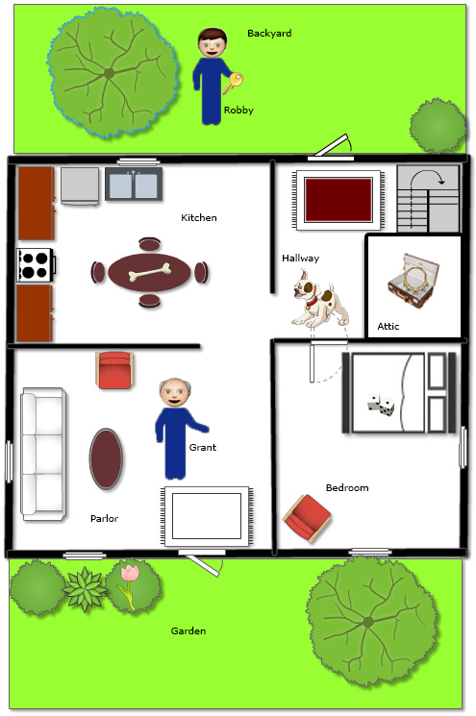**Map** 50 points

You must draw a map either on graph paper or using floor planner software to create a detailed map of the rooms of your game. Draw the rooms to match the descriptions. You must add your items to the rooms as well. The map should be in color. Rooms must be labeled.